**pitch**

1. The rate of vibrations producing a sound ; faster vibrations are high pitch and slower vibrations are low pitch.

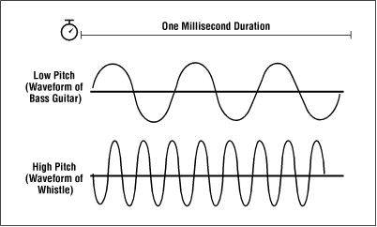

2.the steepness of a slope, especially of a roof.



3 . soccer (football) playing field.

**4.**  to throw or toss



5. trying to persuade someone to buy something.

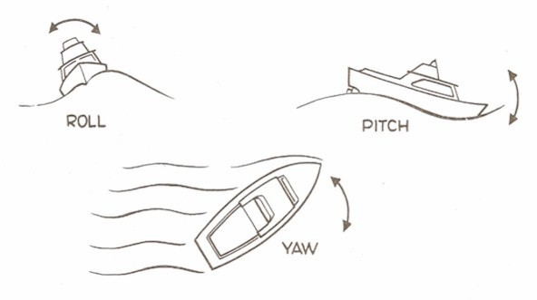

1. Oscillate (swaying) around a horizonal axis, so that the front and back move up and down.

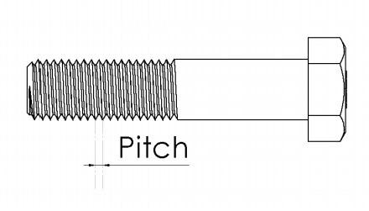

1. the distance between the threads on a screw.

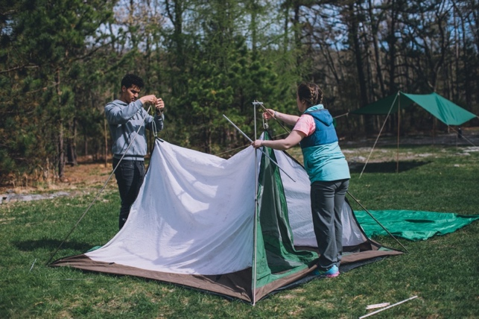

1. set up and fix in a definite position (especially a tent).